
DecoVibe

Metal Wall Art Category

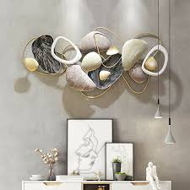
This modern abstract metal wall décor is a perfect blend of creativity and luxury design.
Expertly crafted with high-grade iron and finished with premium hand-painted detailing,
it adds a bold and sophisticated statement to any interior space.

The elegant combination of metallic textures and contemporary structure makes it ideal
for living rooms, bedrooms, offices, and hall areas. Its durable construction ensures
long-lasting performance while the rust-resistant coating maintains its shine over time.

A true masterpiece for those who appreciate artistic décor and modern elegance in their home.

